Instructions

WWW.VUTUBE.EDU.PK

CS101 Introduction to Computing
Final Term Examination - February 2005
Time Allowed: 150 Minutes

Please read the following instructions carefully before attempting any question:
1. This examination is closed book, closed notes, closed neighbors.
2. Answer all questions.
a. There is no choice.
b. You will have to answer all questions correctly in this examination to get the
maximum possible marks.
3. Do not ask any questions about the contents of this examination from anyone.
a. If you think that there is something wrong with any of the questions, attempt it to
the best of your understanding.
b. If you believe that some essential piece of information is missing, make an
appropriate assumption and use it to solve the problem.
4. Examination also consists of multiple-choice questions [MCQs]. Choose or Highlight
only one choice as your answer.
a. If you believe that two (or more) of the choices are the correct ones for a
particular question, choose or highlight the best one.
b. On the other hand, if you believe that all of the choices provided for a particular
question are the wrong ones, choose or highlight the one that appears to you as
being the least wrong.
5. All Web development questions should be answered using the HTML/JavaScript syntax.
**WARNING: Please note that Virtual University takes serious note of unfair
means. Anyone found involved in cheating will get an `F` grade in this course.

Total Marks: 50
Questions: 14
Question No. 1
Micro controller
1 Are faster then microprocessor
2 Is another name for microprocessor?

Total

Marks : 2

3 Are complete computer on a chip
4 Cost thousands of dollar per piece

Question No. 2

Two major types of software are
1 Application Software , System Software
2 Application Software , Database Software
3 System Software , Database Software
4 Database Software , Embedded Software

Question No. 3

Marks : 2

Marks : 5

How Operating System software does manage a device when a particular application is
executed? Explain with at least one example?

Question No. 4
Word representing the protocol in URL http://www.microsoft.com is
1 www
2 Microsoft
3 microsoft.com
4 http
Question No. 5
What do you know about WWW and what are the basic elements of web design?

Question No. 6
What do you know about Neural Networks and give any two examples.

Question No. 7
Marks : 2

Marks : 5

Marks : 5

Marks : 5

Define and explain Greedy Algorithm briefly. You are also required to give key advantage and
an example of Greedy Algorithm.

Question No. 8
Marks : 6

Determine the correct reserved words of JavaScript from the following list and explain them
briefly.
1 document
2 read
3 alert
4 delete
5 function
6 comment

Question No. 9
Discuss any three issues/characteristics of Data Management.

Question No. 10

Marks : 6

Marks : 11

Write function using JavaScript. The name of function will be "display( )". The "display( )"
function will display the following string as shown below:
X3 + Y2
[Hint: Use string methods sub( ) and sup( )]
The "display( )" function should be called at onLoad event.

Question No. 11
Consider the following code
pitch = "hard"
bowler="slow"
if ( (pitch == "hard") || (bowler == "fast") )
myStatus = "Bouncer" ;
else
myStatus = "Short Pitch" ;
Variable myStatus will contain the value:
1 Bouncer
2 Short Pitch
3 Hard
4 Slow

Question No. 12

What does the following JavaScript code
function changeBgcolor()
{
oldColor = window.document.bgColor;
window.document.bgColor = "pink";
window. alert("The old color was " + oldColor);
}

1 Change the Color of Window document to pink and nothing else

Marks : 2

Marks : 2

2 Change the Color of Window document to pink and display the name of old Color in a
dialogue box
3 Change the Color of Window document to Blue and displays name of old color in a
dialogue box
4 Create a form in window document

Question No. 13

Marks : 10

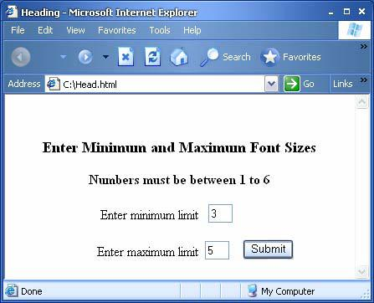

Examine and explain the logic of following pseudo code:
Let the decimal number be an integer x, x > 0
Let the binary equivalent be an empty string y
Repeat while x > 0
{
Determine the quotient & remainder of x ÷ 2
y = CONCATENATE( remainder, y )
x = quotient
}
Print y
Stop

Question No. 14 M

Marks : 12

You are required to develop a web page using HTML and JavaScript. First page should take
two inputs as maximum and minimum limit as shown in Fig 1.1. The first input must be
greater than or equal to 1 and the second input must be less than or equal to 6. Minimum
limit should be less than the Maximum limit. Generate Headings by this minimum and
maximum limit as shown in Fig 1.2. The Headings must be generated when Submit button is
clicked.
[Example: Min Limit: 3 and Max Limit: 5, So the heading H3, H4 and H5 will be generated.]

Fig: 1.1

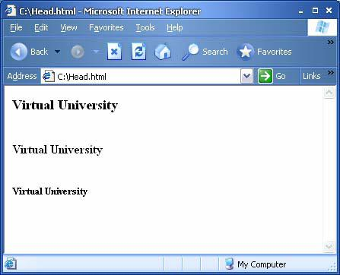

Fig: 1.2

